Investigating productivity-compensation decoupling across industries and income levels from 1997-2019.

# Introduction

What I want to get across:

* Data shows that median wages and productivity were joined since 1997 and decoupled around 2010.
  + Due to data constraints, a more longitudinal analysis is not possible.
* Exactly how much have each grown since 1997.
* While the ONS says that the UK has not experienced decoupling, it does not include median compensation and consequently it does not account for the rise in inequality since 1997.
  + [“The UK has not experienced decoupling between pay and productivity reported in other advanced countries” UK ONS](https://www.ons.gov.uk/economy/economicoutputandproductivity/output/articles/trendsintheuklabourshare1997to2023/2024-11-25)
* As Stansbury and Summers point out, “just as two series apparently growing in tandem does not mean that one causes the other, two series diverging may not mean that the causal link between the two has broken down.”
  + There may be orthogonal factors keeping wages low even as productivity growth has been acting to raise wages.
    - This has not been fully grasped by some commentators and authors.
      * [“The typical worker may not feel much benefit”. UK](https://www.lse.ac.uk/News/Latest-news-from-LSE/2021/k-November-21/Wages-of-typical-UK-employee-have-become-decoupled-from-productivity)
      * [“Unless you are rich, GDP growth isn’t doing much to raise your income anymore.” US](https://www.economist.com/democracy-in-america/2013/12/16/a-defining-issue-for-poor-people)

# Introduction II

From 1997 to 2010, gross median hourly earnings and labour productivity grew in tandem. Since 2010, however, the growth of both variables has diverged.

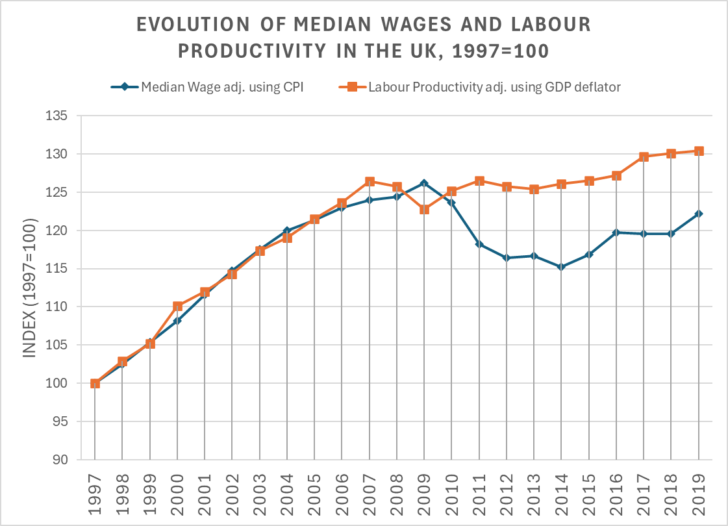

Figure 1

Over the period 1997-2010, median compensation and productivity each grew roughly 25% in real terms; since 2010, median compensation decreased by 1.2% while productivity grew by a further 4.22%. Combining these results, we see that over 1997-2019, compensation grew by 22.15% whereas productivity grew by 30.42%.

Stansbury & Summers (2018, p. 4), in their analysis of ‘delinkage’ in the US, make a critical point – just as correlation does not imply causation, two series appearing to decorrelate, as they do in figure 1, does not necessarily imply a causal break: there may be orthogonal factors lowering wages, even while increases in productivity act to raise them. This point has been disputed – regarding decoupling in the US, Bivens & Mishel (2015) write, “… productivity still managed to rise substantially in recent decades. But essentially none of this productivity growth flowed back into the paycheques of typical American workers.” In the UK, Teichgraber and Van Reenen (2021) suggest that “the decoupling of productivity and median wages means the typical worker may not feel much benefit.”

The debate is an important one, especially when the connection between productivity and living standards is often taken as a stylised fact, notably by Krugman (1990, p. xx) in his popular remark:

“Productivity isn’t everything, but, in the long run, it is almost everything. A country’s ability to improve its standard of living over time depends almost entirely on its ability to raise its output per worker.”

Investigating Stansbury & Summer’s (2018) argument is complicated by the fact that what exactly is meant by “decoupling” or “delinkage” is not yet fully established. Some define decoupling as solely a divergence between the *median* compensation and mean productivity growth rates (Bivens & Mishel, 2015), while others suggest nuance to differentiate between mean and median compensation decoupling (Pessoa & Van Reenen, 2013; Stansbury & Summers, 2018; Ciarli, Salgado, & Savona, 2018; Ciarli, Di Ubaldo, & Savona, 2021); still other parts of the literature argue that decoupling should only be seen as a persistent fall in labour’s share of income (Feldstein, 2008; Brill et al., 2017), where:

This final definition of decoupling is what led the ONS (2024) to state that “the UK has not experienced the decoupling between pay and productivity reported in other advanced countries”. Indeed, the labour share of income in the UK has actually risen in recent years, shown in figure 2, contrary to what one might first think from figure 1.

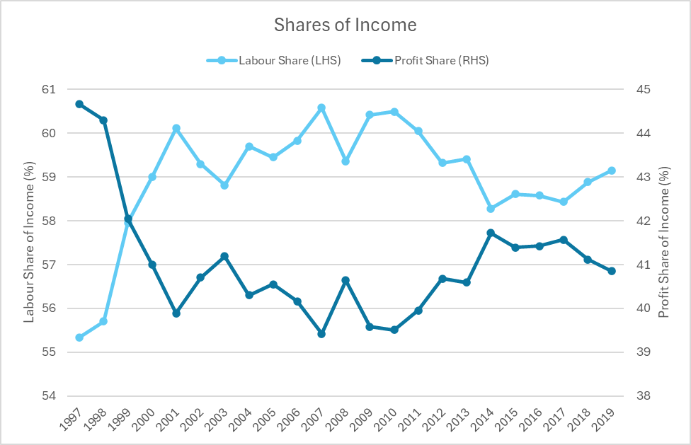

Figure 2

If we are concerned solely with the labour share, the productivity-compensation question is analysed only in the context of the production process. However, if we are concerned also with the typical worker’s purchasing power, the question extends to encompass both production and consumption, because an increase in consumer prices can decrease real labour income, notwithstanding a decrease in the labour share. Figure 3 shows that the prices producers receive – and can thus pass on to workers – have grown slower in the service and manufacturing sector than consumer/retailer prices, implying that even if firms’ revenues were shared with employees in constant proportion, the real value of that share could be declining.

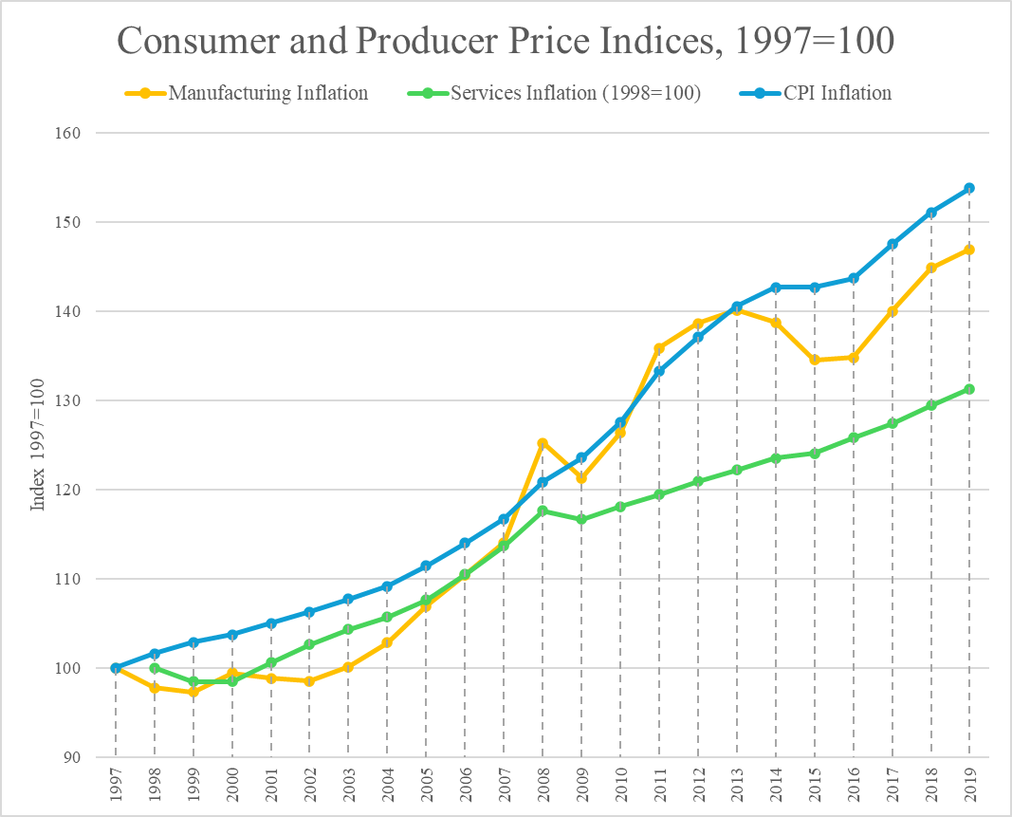

Figure 3

Furthermore, distinguishing between the ‘typical’, i.e., median, rather than the ‘average’, i.e., mean, worker allows broader statements to be made on how productivity translates to living standards in an environment where income inequality has risen – see figure 4 – and thus improvements to average compensation may have less of a connection with the typical employee as is often thought.

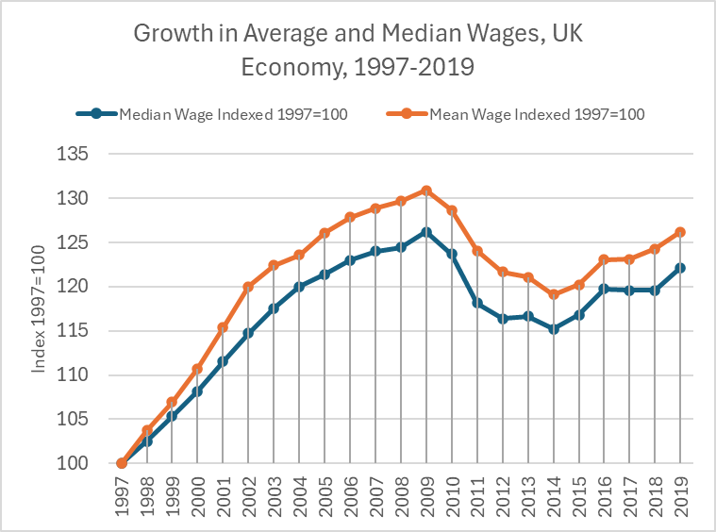

Figure 4

For these reasons, this paper will follow the terminology of Pessoa & Van Reenen (2013) and Teichgraber & Van Reenen (2021), by using ‘gross’ and ‘net’ decoupling to refer to the two different phenomena, where net decoupling refers to changes in the labour share, while gross decoupling refers to a divergence between median wages and average labour productivity, the former adjusted using consumer prices.

This paper will build primarily on work by Stansbury & Summers (2018) and Pasimeni (2018) by applying their methodology to the UK. Stansbury & Summers (2018) measured the elasticity of productivity on mean, median and ‘production/non-supervisory’ compensation in the US, while Pasimeni (2018) investigates only mean compensation in a panel of mostly EU member states. In order to analyse both types of decoupling and to fully assess Krugman’s (1990) famous remark, this paper will focus primarily on median but also mean incomes, ignoring production/non-supervisory income as there is no dedicated dataset for this in the UK and because median income provides a clearer indicator of typical income. Contributions by Pessoa & Van Reenen (2013), Ciarli, Salgado & Savona (2018), Brocek (2019), Ciarli, Di Ubaldo & Savona (2021), Teichgraber & Van Reenen (2021) and Nasir et al. (2022) constitute the primary knowledge base of the status of the productivity-compensation nexus in the UK. As in Brocek (2019), this paper will further extend the analysis by examining the elasticity of productivity on not only median wages, but also across different wage percentiles and across different sectors; furthermore, this paper will build on Brocek (2019) by implementing previously key robustness checks and by further synthesising Brocek’s (2019) methodology with Stansbury & Summers (2018). This paper concludes by finding a strong effect of productivity on both median and mean wages, indistinguishable from 1-to-1, across a range of specifications; to finalise, we analyse the technological change hypothesis for why the two metrics have diverged.

# Previous Literature

The existing body of literature in the UK can be roughly grouped into two separate sections, broadly speaking, those which deal with quantitative regression analyses and those that deal with qualitative decoupling analyses. This section will analyse the benefits and drawbacks of each paper and conclude by explaining where new contributions can be made by implementing novelties from Stansbury & Summers (2018).

Ciarli, Salgado & Savona (2018) investigate how low-wage workers benefit from productivity growth in the UK; by using matched employer-employee combinations, they study effects of productivity at the firm, industry, and local labour market level. They find that, in the period 2011-2015, a 1% labour productivity (LP) increase led to an insignificant, 0.151%, and 0.225% increase in median wages at the firm, industry, and local labour market levels, respectively. For all wage percentiles below the median, a 1% LP increase led to either insignificant or negative wage changes at all levels – except in the lowest percentile at the firm level, where a 0.01% increase was identified. These findings are mirrored by Ciarli, Di Ubaldo & Savona (2021) who investigate the productivity-compensation nexus in London, Slough & Heathrow, and the rest of Great Britain at the local labour market level in the period 2004-2014; they found that a £1 increase in productivity led to a £0.35 and £0.26 increase in median wages in local labour markets across a 5-year and 10-year time horizon, respectively. While the use of absolute rather than relative measures is slightly opaque, the authors maintain that these findings signify gross decoupling.

Both papers paint a dismal picture of the state of gross decoupling in the UK but there are significant methodological improvements which could be made to paint a more accurate picture. First, as Ciarli, Salgado & Savona (2018, p. 15) point out, their findings reflect contemporaneous changes in wages due to productivity, and thus cannot capture lagged effects of productivity; these effects, however, are important – the authors themselves state that firms may postpone wage increase to gain a competitive advantage or to recover from losses, and Stansbury & Summers (2018) point out that lagged effects may exist because firms take time to discern to what extent increases in output are due to labour productivity. This problem remains unaddressed in Ciarli, Di Ubaldi & Savona (2021).

Pessoa & Van Reenen (2013) and Teichgraber & Van Reenen (2021) investigate changes to both net and gross decoupling. Net decoupling, , is equivalent to a decline in the labour share, and can be measured as the difference between labour productivity and *mean compensation* where both are adjusted by an output price deflator; gross decoupling, , which is depicted in figure 1, is defined as the difference between productivity and *median wages*, deflated by an output and consumer price deflator, respectively. The difference between the two measures can be decomposed to:

Where represents differences between mean and median wages, represents differences between wages and total compensation per hour, and represents differences between producer/output and consumer/retailer prices. Both papers argue that a rise in inequality and a shift in the composition of compensation toward non-wage benefits, such as pension contributions, are the predominant drivers of gross decoupling; the impact of differences in output and consumer price deflators is found to be very little – see figure 5.

Figure 5 – source: Teichgraber & Van Reenen (2021, p. 18). Decoupling decomposition in the UK.

The complication, however, is that while this qualitative analysis of the productivity-compensation gap is interesting insofar as we can clearly visualise and decompose the decoupling, it lacks the quantitative statistical analysis to inform us of whether the productivity-compensation causal link is broken or simply decorrelated due to orthogonal factors.

Nasir et al. (2022) utilise a NARDL model to estimate the effects of a 1% rise in LP on real average weekly wages in the UK. The first paper to research the asymmetrical effects of productivity on wages, they find that, in the short run, a +1% productivity shock leads to a +1.105% wage increase; surprisingly, they also find that a -1% productivity shock leads to a +0.513% wage increase – again in the short run. Contemporary effects of productivity on wages are insignificant, supporting the hypothesis that it is necessary to include lags to capture the full effects of productivity. In the long run, a +1% productivity shock leads to a +2.416% increase in wages and a -1% productivity shock leads to a +1.123% increase in wages. Both short- and long-run results clearly suggesting strong wage downward stickiness. Control variables used in the study include inflation, GDP growth, and unemployment. These variables are theoretically understood to impact wages via competitive dynamics, efficiency or fair wages à la Stiglitz & Shapiro (1984) or Akerlof & Yellen (1990), or inflationary expectations. In the long run, these controls are not found to have any significant effect and productivity is left the sole determinant of wages; however, this link is not sufficient to contradict Pessoa & Van Reenen’s (2013) findings – as is claimed – or Teichgraber & Van Reenen's (2021) conclusion that gross decoupling has increased, given that Nasir et al. (2022) do not investigate median wage growth.

Finally, Stansbury & Summers (2018) provide, in this paper’s opinion, the best methodology to properly unite concerns raised by rising inequality, delayed productivity-compensation gains, and qualitative-quantitative analytic disparities. First, Stansbury & Summers (2018) find elasticities for the median, mean, and ‘production/non-supervisory’ wages in the US as 0.7-1 for the former two, and 0.4-0.7 for the final. Analysing all three variables allows the effects of inequality to be better captured via the difference between these coefficients. Second, to account for lagged effects, Stansbury & Summers (2018) use moving-averages – something which Pasimeni (2018) and Brocek (2019) also do.

While Brocek (2019) provides the clearest example of how to transition Stansbury & Summers’ (2018) regression model to the UK, there are a number of novelties which could further improve the analysis. First, Stansbury & Summers (2018) distinguish between gross and net productivity, where the latter reflects deductions made to GDP after subtracting capital depreciation – see figure 6.

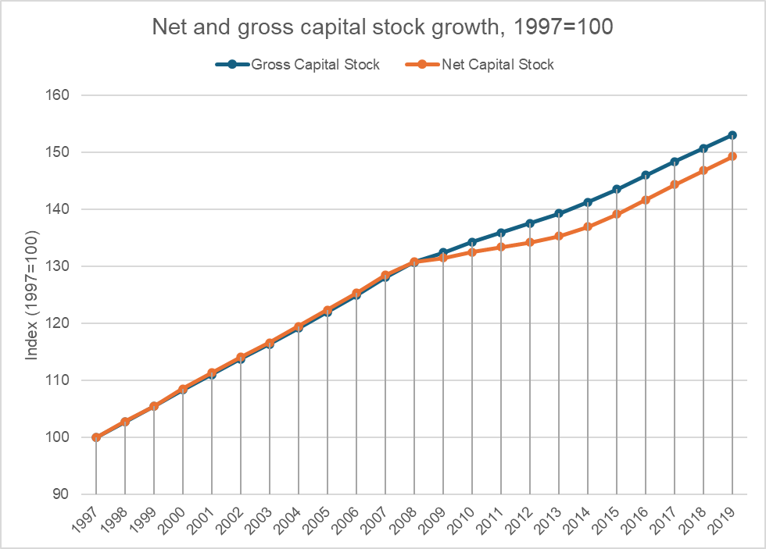

Figure 6

Because net domestic product (NDP) more accurately reflects the value of goods and services in an economy available for consumption (ONS, 2023), using it as the basis for productivity means we are better capturing what income is available to be split between labour and profit. Second, Stansbury & Summers (2018) restrict unemployment data to the rate for 25-54 year-olds to avoid capturing demographic shift effects. Finally, as well as using moving averages, the Stansbury & Summers (2018) also use an ARDL model, further modifying time horizons.

By implementing these improvements, this paper will build on previous literature in the UK and more fully answer the question of how, precisely, productivity growth leads to changes in income and living standards.

# Empirical Strategy

As stated, we will regress a plethora of different models, investigating the effects of productivity on both average and median wages. The variable term and productivity () will be a catch-all for both kinds and nuance will be introduced when results are presented.

We first estimate a simple model, regressing real median wages on real productivity – logs are used to estimate elasticities rather than absolute units:

We control for unemployment as in Stansbury & Summers (2018) because unemployment is likely to affect bargaining dynamics à la the *efficiency wages* theory of Stiglitz & Shapiro (1984) wherein higher unemployment increases employee’s opportunity cost of being fired for substandard performance; furthermore, it likely affects compensation in the short-run, because high unemployment is associated with an economic downturn, where pay rises will be rare regardless of productivity changes. This gives us:

Finally, we account for lagged effects; this is done by regressing using three-year moving averages rather than simply contemporaneous -time variables:

## Data

Data used is provided primarily by the Office for National Statistics (ONS), although some data is also taken from the Bank of England’s “A millennium of macroeconomic data” dataset. All presented data has been logged to reduce variance and is plotted on a natural log scale.

Median wages from 1987 can be found for the entire population, although they are given as *median gross weekly earnings* (ONS, 2023); for hourly rates, data is only available from 1997 (ONS, 2024). Alternatively, an index of real average labour compensation (adjusted with a consumption deflator) is available from 1971 (ONS, 2025). While Pessoa & Van Reenen (2013) and Stansbury & Summers (2018) are correct to point out the important difference between gross wage and total compensation, median compensation in the UK is not available; as such, median earnings will unfortunately be underestimated. It is likely not a level effect: non-wage benefits have been growing as a percent of the total pay packet (Pessoa & Van Reenen, 2013; Teichgraber & Van Reenen, 2021); as a result, this will likely skew regression results. See figure 7 for a visual comparison between the three different measurements.

|  |  |
| --- | --- |
|  |  |
|  | |
| Figure 7 | |

Labour productivity is available from 1760 (Bank of England, 2024), although this is calculated using annual GDP rather than Net Domestic Product (NDP), or value added (either gross or net) – the latter of which is common in some modern ONS publications (ONS, 2022). Data on productivity hours worked is available as an index since 1971 (ONS, 2025) and this is combined with GDP, NDP, GVA and NVA data to find values for productivity – see figure 8.

Figure 8

Finally, unemployment figures are available from 1855. To avoid capturing effects from demographic shifts, unemployment data from the 25-49 year-old age range is used to check for robustness – this data is only provided from 1997 onwards, however – see figure 9.

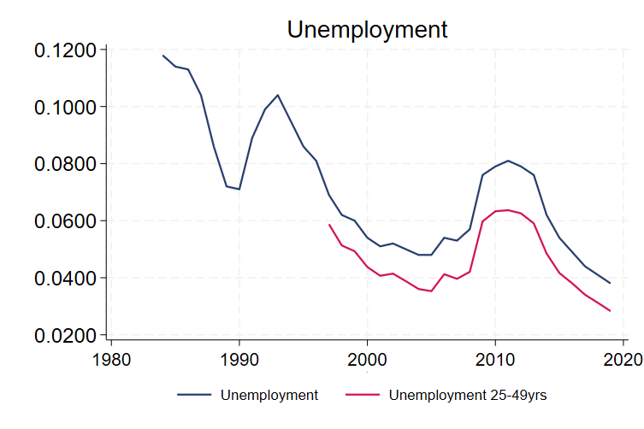

Figure 9

## Baseline

The baseline regression will use data available from 1987 onward:

|  |  |
| --- | --- |
|  | Gross weekly median wages |
|  | Net Domestic Product per annual hours worked |
|  | Whole economy unemployment rate |

To account for differences in measurement between median weekly wages and productivity per hour, we will control for hours worked () in our model:

The final step of constructing the baseline specification is to test for stationarity and cointegration to evaluate whether trending behaviour should be removed by differencing. Each variable is tested for serial correlation and stationarity to calculate its order of integration – these results are presented below.

|  |  |
| --- | --- |
| **Variable** | **Order of Integration** |
|  |  |
|  |  |
|  |  |
|  |  |

See Appendix x for how this was calculated.

Our baseline equation is therefore:

# Baseline Results

|  |  |  |
| --- | --- | --- |
| Variable | Serial Correlation Lags |  |
|  | 1 | RW w/ drift |
|  | 0 | RW w/no drift w/ trend |
|  | 1 | RW w/no drift w/ trend |
|  | 3 | RW w/ drift |

|  |  |  |
| --- | --- | --- |
| Variable | Serial Correlation Lags |  |
| D | 0 | RW w/no drift |
| D | 0 | Stationary |
| D | 0 | Undetermined – likely RW w/no drift |
| D | 2 | Stationary |

|  |  |  |
| --- | --- | --- |
| Variable | Serial Correlation Lags |  |
|  | 0 | Stationary |
|  | 0 | Stationary |

The baseline regression equation analysed by Stansbury & Summers (2018) is:

# Data

This paper uses data provided by the Office for National Statistics (ONS).

For median wages, data was collected from the New Earnings Survey (NES) for the years 1985-2004, and the Annual Survey of Hours and Earnings (ASHE) for the years 2004-2019; these data points having been already combined by the ONS (2023). Data on different income percentiles are taken from ASHE tables, which have been synthesised by the ONS with NES data from 1997-2004 – from 1985-1997, the only income distributions available are quartiles, which will also be analysed.

For productivity, both gross and net measures are collected. Net measures form the baseline analysis, whereas gross measures are used as robustness checks. Slight nuances exist with how exactly productivity ought to be calculated – it is disputed whether or not *imputed rental values*, typically used to capture the value of housing currently owner-occupied, should be excluded from value-added calculations (ONS, 2020); however, the ONS only has records excluding imputed rental values from 1997 onward. For the baseline, net productivity from 1985-2019 will be used, and robustness checks will be carried out using 1985-2019 gross productivity and 1997-2019 gross productivity sans imputed rents.

This paper controls for unemployment, hours worked, and inflation (Stansbury & Summers, 2018; Pasimeni, 2018; Nasir et al., 2022). Again, all data is derived from the ONS. As in Stansbury & Summers (2018), unemployment data is restricted, to avoid unintentionally capturing effects of demographic shifts, to the unemployment rate of 25-49 year-olds; robustness checks are calculated using the total unemployment rate instead.

Data sources and descriptions are summarised in Table 1:

|  |  |  |
| --- | --- | --- |
| **Variable** | **Source** | **Notes** |
| Median wage & different wage distributions | (ONS, 2023) |  |
| Average wage | (ONS, 2024) |  |
| Net & gross productivity | (ONS, 2024) |  |
| Unemployment | (ONS, 2025) | Unemployment expressed monthly as a 3-month moving average – yearly data was found by taking 12-month averages. |
| Hours worked | (ONS, 2022) |  |
| Inflation | (ONS, 2025) | CPIH |

# Methodology

## Baseline and Robustness Tests

Productivity is a difficult term to pin down across both the literature and data collection agencies, mainly the ONS. The ONS tends to define productivity as the gross value added – rather than gross domestic output – per hour, whereas Stansbury & Summers (2018) prefer the latter. When accounting for capital consumption (depreciation), they therefore utilise net domestic product, rather than net value added, per hour. This paper used net domestic product as the baseline, however performed robustness analyses with the other three possible definitions of productivity, finding ___.

The baseline regression equation analysed by Stansbury & Summers (2018) is:

This regression equation implements lagged concerns by finding using moving averages across a three-year time horizon. As pointed out in their paper, it is not immediately clear why three-year moving averages should be used. This period is modified to check for robustness, finding ___.

This will be the baseline regression. Data is available for these variables from 1987-2023, however this paper will cut-off analysis at 2019 to avoid employment complications during Covid lockdowns, preferring to focus instead on the decoupling break during the Great Recession. Unfortunately, unemployment data decomposed into different age groups is only available from 1997, so the 25-49 unemployment rate is used as a robustness check to avoid effects from changing demographics, finding ___. Furthermore, data from different percentiles is also only available from 1997 onward, whereas data from different quartiles is available from 1984; consequently analysis regarding income distribution will be split into these two parts.

Alternatively, Pasimeni (2018) and Nasir et al. (2022?) utilise different control variables. Pasimeni’s (2018) baseline regression equation is:

While Nasir et al.’s (2022?) equation incorporates GDP, inflation, as well as unemployment, as control variables.

# Analysis

*Stansbury & Summers (2018, p. 14) equation*

# Evaluation

# Conclusion